<https://www.knightfoundation.org/articles/philadelphia-pickup-truck-expo-2014>

<https://graphicdisplayusa.com/blog/wandering-sukkah-mobile-dibond-art-installation-creates-reflective-space-for-new-yorkers/>

<https://www.escapecampervans.com/blog/artist-contest-help-design-our-newest-model/>

[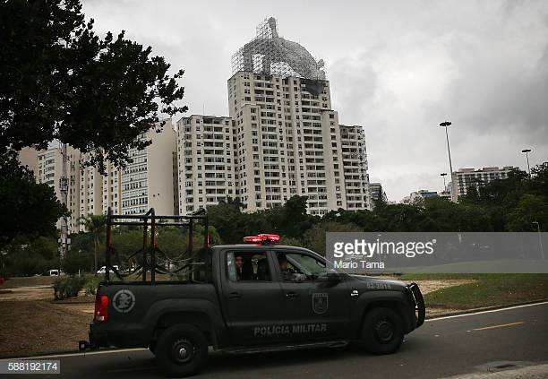](https://www.google.com/url?sa=i&rct=j&q=&esrc=s&source=images&cd=&ved=2ahUKEwjs8YyH-b_jAhXCT98KHSZRCs0QjRx6BAgBEAU&url=https%3A%2F%2Fwww.gettyimages.com%2Fphotos%2Frio-art-installations-celebrate-olympic-athletes&psig=AOvVaw14AG-MLNPoO368y4MDSk1V&ust=1563589732627829)

[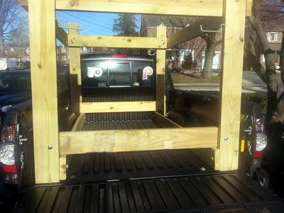](http://2.bp.blogspot.com/-4wnsGPSHFPc/UTw90OwXUrI/AAAAAAAAD4E/Ba-9mUXC-R8/s1600/pickup+rack+end+view.jpg)

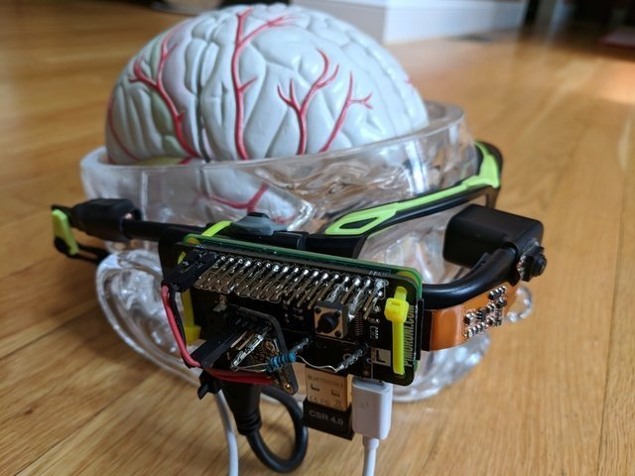

<https://learn.adafruit.com/piglass-wearable-raspberry-pi-computer>